 | Introduction



This document is an outline of FastCap’s Morning meeting. FastCap's morning meeting has helped to develop, support and build our Lean culture more than anything else we’ve done.

FastCap is providing this document in a Word format so that you can customize, edit and change anything that you want to help build your culture.

Remember, building a Lean culture should be personal and unique to your company and people. You can copy us 100% or you can change 99%, it doesn’t matter. The important thing is that you are committed to growing your team on a daily basis and everything else will take care of itself.

There are also many Lean videos on our website (www.fastcap.com) on the right hand side. These videos are designed to be quick 5 minute examples of what Lean looks like in living color. We highly recommend that you utilize this valuable tool. All the videos pertaining to Lean start with the word Lean, for example:
- Lean Morning Improvement Walk
- Lean Morning Meeting
- Lean Typical Daily Improvement
- Lean Desk
- Lean Bathroom

LEAN WORKS!

 | Morning Meeting Agenda

- 7:30-7:55 Leader preps for the meeting
- 7:55 Leader Announces over intercom and walkie-talkie 5 minutes until morning meeting
- 8:00 Good morning FastCap!
- 8:01 Announce tomorrow’s Meeting Leader
- 8:02 Sales Numbers
- 8:03 Mistakes and discussion
- 8:10 Raving Fans
- 8:15 Product Review
- 8:20 Improvement
- 8:25 FastCap Principles
- 8:30 History and Enrichment
- 8:35 Constitution
- 8:40 Stretching
- 8:45 Back to Work

Note:
  - The times are approximate. Our morning meeting generally takes 30 minutes, but can take up to an hour depending on subjects and issues of the day.
  - We have the morning meeting every morning. We do not miss it. It is the most important way we build our culture. In the beginning, our morning meetings were only 5 minutes long. We recommend that you start the same way and make it sustainable.
  - Constant review and testing of the material you cover is critical for retention.
  - We are often asked if we have new employee orientation. The answer is “No.” The morning meeting provides daily orientation and is infinitely more effective.

Leader: This allows the leader to announce who will lead the next morning meeting.
Meeting Checklist

□ Aleksey K.  □ Alexey V.  □ Alisha  □ Andrey  □ Austin  □ Brady  □ Breah  □ Cathy  □ Carina  □ Cindy  □ Clint  □ Daniel  □ David  □ Doug  □ George  □ Graham | □ Irina  □ Jenny  □ Jess  □ K-Lee  □ Kristen  □ Liliya  □ Marina  □ Marla  □ Michelle  □ Mike  □ Nico  □ Paul S.  □ Preet  □ Sandi  □ Tim  □ Yuriy

Leader: This allows the leader to announce who will lead the next morning meeting.

Leader: Read the previous day’s Sales numbers and Discuss any Mistakes listed.
January 2011
Sunday | Monday | Tuesday | Wednesday | Thursday | Friday | Saturday
 |  |  |  |  |  | 1
2 | 3 | 4 | 5 | 6 | 7 | 8
9 | 10 | 11 | 12 | 13 | 14 | 15
16 | 17 | 18 | 19 | 20 | 21 | 22
23 | 24 | 25 | 26 | 27 | 28 | 29
30 | 31
  March 2011
  Sunday | Monday | Tuesday | Wednesday | Thursday | Friday | Saturday
   |  | 1 | 2 | 3 | 4 | 5
  6 | 7 | 8 | 9 | 10 | 11 | 12
  13 | 14 | 15 | 16 | 17 | 18 | 19
  20 | 21 | 22 | 23 | 24 | 25 | 26
  27 | 28 | 29 | 30 | 31
  April 2011
  Sunday | Monday | Tuesday | Wednesday | Thursday | Friday | Saturday
   |  |  |  |  | 1 | 2
  3 | 4 | 5 | 6 | 7 | 8 | 9
  10 | 11 | 12 | 13 | 14 | 15 | 16
  17 | 18 | 19 | 20 | 21 | 22 | 23
  24 | 25 | 26 | 27 | 28 | 29 | 30
February 2011
Sunday | Monday | Tuesday | Wednesday | Thursday | Friday | Saturday
 |  | 1 | 2 | 3 | 4 | 5
6 | 7 | 8 | 9 | 10 | 11 | 12
13 | 14 | 15 | 16 | 17 | 18 | 19
20 | 21 | 22 | 23 | 24 | 25 | 26
27 | 28

  May 2011
  Sunday | Monday | Tuesday | Wednesday | Thursday | Friday | Saturday
  1 | 2 | 3 | 4 | 5 | 6 | 7
  8 | 9 | 10 | 11 | 12 | 13 | 14
  15 | 16 | 17 | 18 | 19 | 20 | 21
  22 | 23 | 24 | 25 | 26 | 27 | 28
  29 | 30 | 31
  June 2011
  Sunday | Monday | Tuesday | Wednesday | Thursday | Friday | Saturday
   |  |  | 1 | 2 | 3 | 4
  5 | 6 | 7 | 8 | 9 | 10 | 11
  12 | 13 | 14 | 15 | 16 | 17 | 18
  19 | 20 | 21 | 22 | 23 | 24 | 25
  26 | 27 | 28 | 29 | 30
  July 2011
  Sunday | Monday | Tuesday | Wednesday | Thursday | Friday | Saturday
   |  |  |  |  | 1 | 2
  3 | 4 | 5 | 6 | 7 | 8 | 9
  10 | 11 | 12 | 13 | 14 | 15 | 16
  17 | 18 | 19 | 20 | 21 | 22 | 23
  24 | 25 | 26 | 27 | 28 | 29 | 30
  31
  August 2011
  Sunday | Monday | Tuesday | Wednesday | Thursday | Friday | Saturday
   | 1 | 2 | 3 | 4 | 5 | 6
  7 | 8 | 9 | 10 | 11 | 12 | 13
  14 | 15 | 16 | 17 | 18 | 19 | 20
  21 | 22 | 23 | 24 | 25 | 26 | 27
  28 | 29 | 30 | 31

  September 2011
  Sunday | Monday | Tuesday | Wednesday | Thursday | Friday | Saturday
   |  |  |  | 1 | 2 | 3
  4 | 5 | 6 | 7 | 8 | 9 | 10
  11 | 12 | 13 | 14 | 15 | 16 | 17
  18 | 19 | 20 | 21 | 22 | 23 | 24
  25 | 26 | 27 | 28 | 29 | 30
  October 2011
  Sunday | Monday | Tuesday | Wednesday | Thursday | Friday | Saturday
   |  |  |  |  |  | 1
  2 | 3 | 4 | 5 | 6 | 7 | 8
  9 | 10 | 11 | 12 | 13 | 14 | 15
  16 | 17 | 18 | 19 | 20 | 21 | 22
  23 | 24 | 25 | 26 | 27 | 28 | 29
  30 | 31
  November 2011
  Sunday | Monday | Tuesday | Wednesday | Thursday | Friday | Saturday
   |  | 1 | 2 | 3 | 4 | 5
  6 | 7 | 8 | 9 | 10 | 11 | 12
  13 | 14 | 15 | 16 | 17 | 18 | 19
  20 | 21 | 22 | 23 | 24 | 25 | 26
  27 | 28 | 29 | 30
  December 2011
  Sunday | Monday | Tuesday | Wednesday | Thursday | Friday | Saturday
   |  |  |  | 1 | 2 | 3
  4 | 5 | 6 | 7 | 8 | 9 | 10
  11 | 12 | 13 | 14 | 15 | 16 | 17
  18 | 19 | 20 | 21 | 22 | 23 | 24
  25 | 26 | 27 | 28 | 29 | 30 | 31

 | Leader: Our goal is for people to rave about our company. This is where emails and letter are read out loud to recognize our team for exceptional service.


Raving Fans

Examples of how FastCap blows people away!!

Example Letters

- “Hi Kenzie! I want you to know that I am very grateful for what you did for me. You provided such friendly customer service and went the extra mile. Please forward this message to your supervisor. I want to extend a compliment to an excellent employee!”
Thanks, Lisa

- “Hi Paul! Thank you for opening up your doors and letting us in for the Learn to See Lean Tour. Being able to see what you do is encouraging and impressive. I have seen my fair share of “World Class” companies over the years and your company by far has been one of the best…hands down.
We are considering ourselves lucky to be able to tour with you and Jon in Japan. Please
convey our group’s big “Thank you” to your employees. Their passion for continuous improvement and working together slapped me in the face the minute we walked in the door.
Kudos!”
Jack Louie

- “Hi FastCap! I just wanted to thank you for all your support. I am proud to be selling your line, the name is like selling Kleenex… the name is so recognized. Your staff does an excellent job and is very helpful and customer driven.”
Thanks, Roger York

- “Hi Jenny! Geez, you make it hard to stay mad. You (and FastCap) have provided absolutely
outstanding customer service. I received the HOD’s today – TODAY, the day after our last communication. Before I opened my little handyman business, I spent decades providing and managing customer support operations in the computer industry. I would have LOVED to have had an employee like you.
Thanks for restoring my faith in (at least one) American business.”
Don Meyers

- “Hi Clint! Thank you for escorting me through your facility today for our annual safety audit. As usual, your facility stands front and center in tidiness. Your record keeping is impeccable and always up-to-date, and all the personnel are always aware of each others’ presence and safety awareness. My rating gives you an A-. It is rare for me to hand out A’s.”
Frank Enriquez

 | Leader: Every day review one of our products so that our team is well-trained with hands-on information.

Product Review

The leader should be prepared to do the following:

- Refer to the catalog to find the next product to be reviewed.
- Go to our website and queue up the product video (when available).
- Get the product to explain and pass around a sample.
- Talk to Paul/Mike/Andrey/Jon about any additional technical info and additional demonstration for the group.
- Encourage questions about the product and test for comprehension.
- Cross off the product in the catalog.

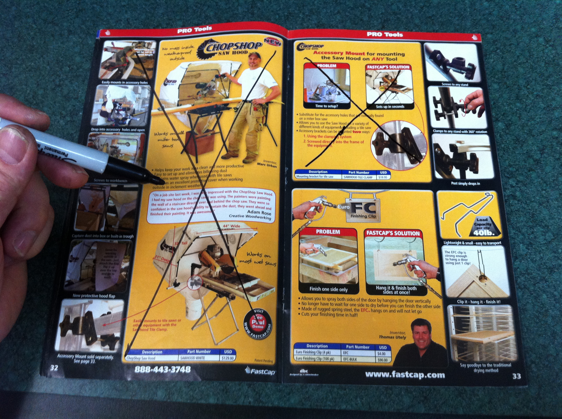

Leader: Check with Andrey and queue up the most recent improvement video that has been made.

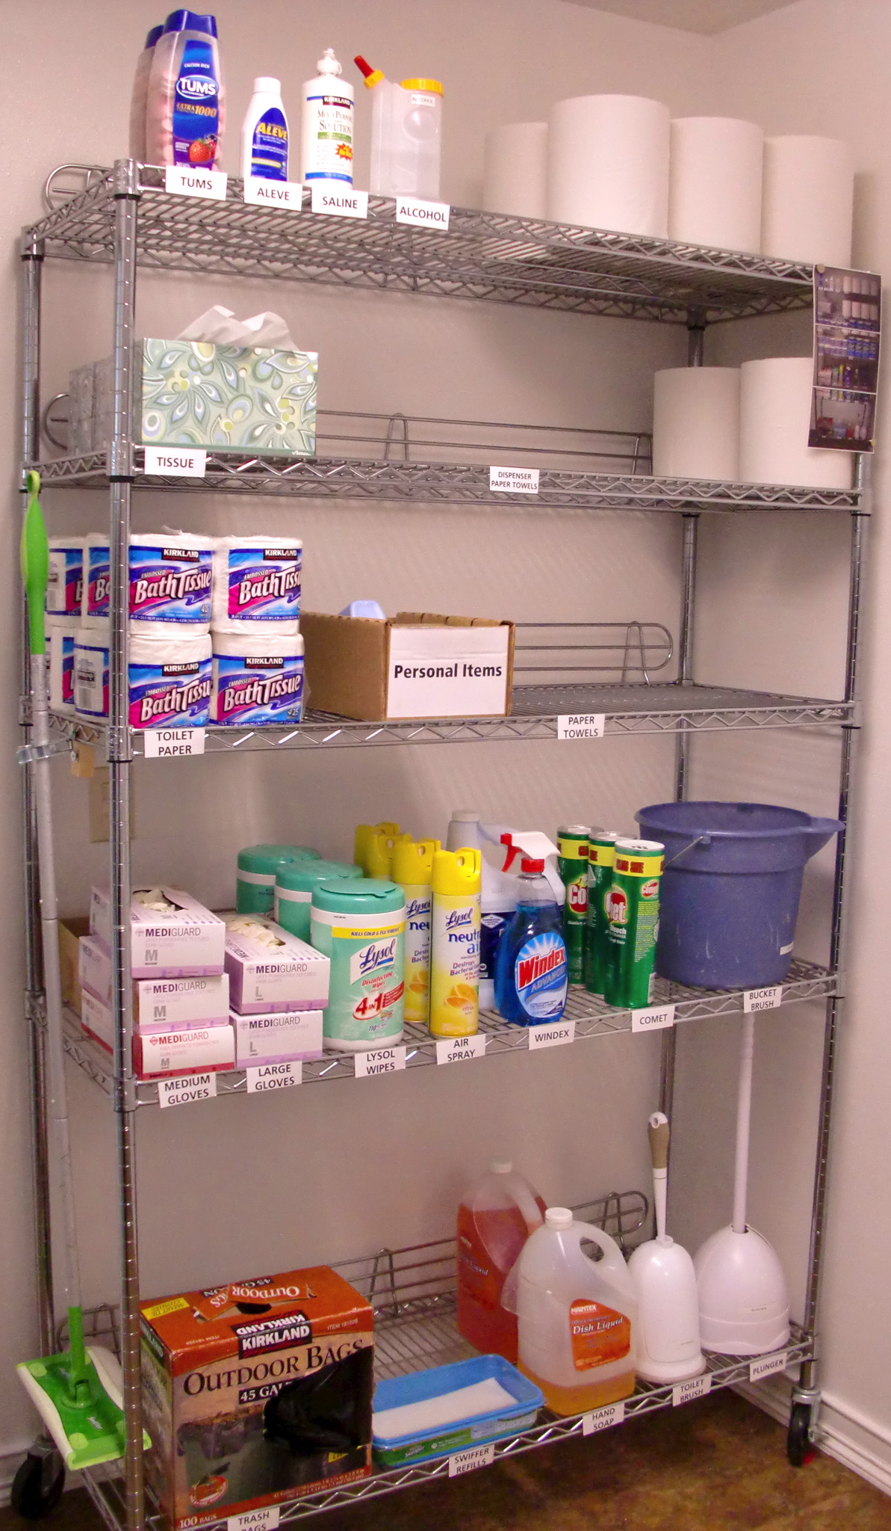
Improvements
Leader calls on 6 people everyday about their current morning improvement.

Every day we focus on an improvement that has been made. Because everyone is required to make one 2 second improvement a day, it is easy to showcase and celebrate one improvement every day. We take the improvements that are the most compelling and actually produce short videos showing the problem and improvement. These videos are then posted on our website under Lean Improvements.

The concept of reviewing an improvement every day comes from the idea that if you want to make a culture stick you must do the following 3 things:

- Create an expectation: Our expectation is that everyone makes a 2 second improvement everyday.

- Inspect the expectation: This is done in the first hour of every day during the Morning Improvement walk where we inspect the improvements that every team member is making.

- Reinforce the expectation: This is done by showing everyone videos of the improvements being made on a daily basis. Note: in the beginning we reviewed improvements by walking from department to department. This method may be effective for smaller companies, however as we grew it was more effective to make videos of the improvements and show them in the morning meeting.

Leader: Call on 6 people who are not yet checked off.
Improvement Checklist – Ask 6 people at RANDOM

□ Aleksey K.  □ Alexey V.  □ Alisha  □ Andrey  □ Austin  □ Brady  □ Breah  □ Cathy  □ Carina  □ Cindy  □ Clint  □ Corrie  □ Daniel  □ David  □ Doug  □ Galina  □ George  □ Graham  □ Irina | □ Jenny  □ Jess  □ Jon  □ Josh  □ K-Lee  □ Kristen  □ Liliya  □ Lyuda  □ Marina  □ Marla  □ Michelle  □ Mike  □ Nico  □ Paul A.  □ Paul S.  □ Preet  □ Sandi  □ Tim  □ Yuriy  □ Vlad

Leader: Read one principle and discuss with group the meaning and how to apply it at work and home.

FastCap’s 20 Principles

- What is the purpose of FastCap? Grow People.

- FastCap is always looking for a way to make things… Faster, Safer and Simpler.

- Winston Churchill said these words… “Action This Day”.

- When we walk away from something we… “Leave It Better Than You Found It”.

- Our job title is… Process Engineer.
- Everything of value comes after… Much hard work.

- Our goal each day is to make one… Two second improvement.

- The most powerful word in the human language is… A Person’s Name.

- Enjoy your day to the fullest by… Doing the Hard thing First.

- To understand the real issue, we must ask… Why 5 times.

- When discussing a problem, we need to… Go and See.

- What must we do if we want to understand our actions? Hansei (reflect).
- Real learning comes when you ask… Questions.

- What did Bob Taylor say? Responsible for things and people.

- "I'll trade all the intelligence in the world for someone with vision".

- Toyota never attempts to improve anything unless they can… Cut the waste in half.

- Hold each other accountable. 2 sides- Who calls it out / Who did it (be humble)

- Your success at FastCap will be determined by the fact that you are… Never Satisfied.

- Toyota’s success is the result of the relentless pursuit of … Building a Culture.

- How do you make a vision stick?

Leader: Call on one person who is not checked off yet.
Principle Checklist

□ Aleksey K.  □ Alexey V.  □ Alisha  □ Andrey  □ Austin  □ Brady  □ Breah  □ Cathy  □ Carina  □ Cindy  □ Clint  □ Corrie  □ Daniel  □ David  □ Doug  □ Galina  □ George  □ Graham  □ Irina | □ Jenny  □ Jess  □ Jon  □ Josh  □ K-Lee  □ Kristen  □ Liliya  □ Lyuda  □ Marina  □ Marla  □ Michelle  □ Mike  □ Nico  □ Paul A.  □ Paul S.  □ Preet  □ Sandi  □ Tim  □ Yuriy  □ Vlad

Leader: Call on one person who is not checked off yet.
8 Wastes Checklist

□ Aleksey K.  □ Alexey V.  □ Alisha  □ Andrey  □ Austin  □ Brady  □ Breah  □ Cathy  □ Carina  □ Cindy  □ Clint  □ Corrie  □ Daniel  □ David  □ Doug  □ Galina  □ George  □ Graham  □ Irina | □ Jenny  □ Jess  □ Jon  □ Josh  □ K-Lee  □ Kristen  □ Liliya  □ Lyuda  □ Marina  □ Marla  □ Michelle  □ Mike  □ Nico  □ Paul A.  □ Paul S.  □ Preet  □ Sandi  □ Tim  □ Yuriy  □ Vlad

8 Deadly Sins of Waste

- Overproduction

- Waiting

- Transportation

- Inventory

- Motion

- Overprocessing

- Defective Units

- Loss of Employee Potential

Leader: Call on one person who is not checked off yet.

 | Leader: Queue up and review the video, audio or book that provides our History and Personal Improvement lesson for the day.

History
Ask What Else & Say Excellent


Examples:
America the Story of Us video.
Top 100 people of the Century video.
Today in History

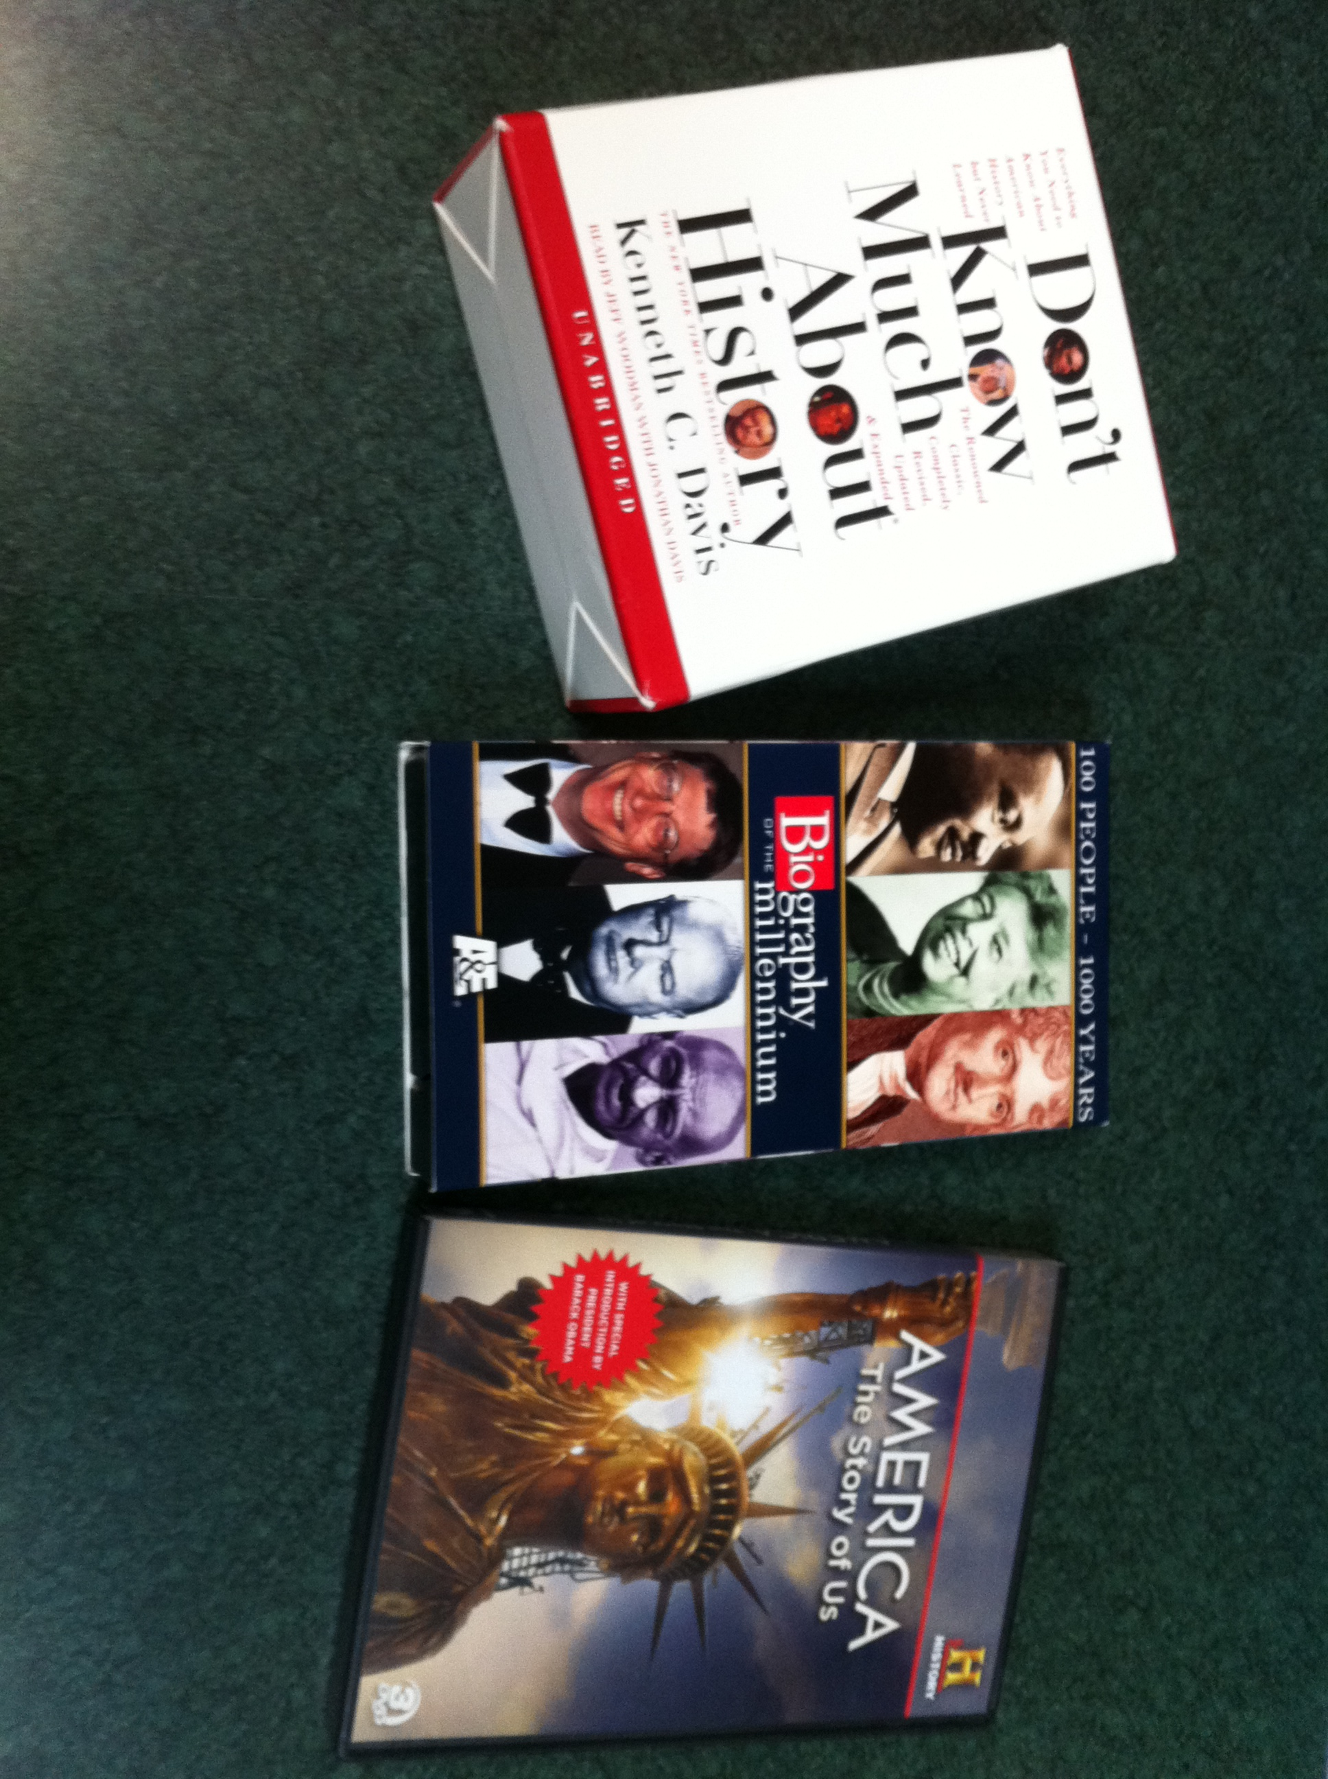

Personal Growth/Enrichment

Examples:
Read one page from book or listen to 5 minutes audiobook.
Good to Great,
The Toyota Way
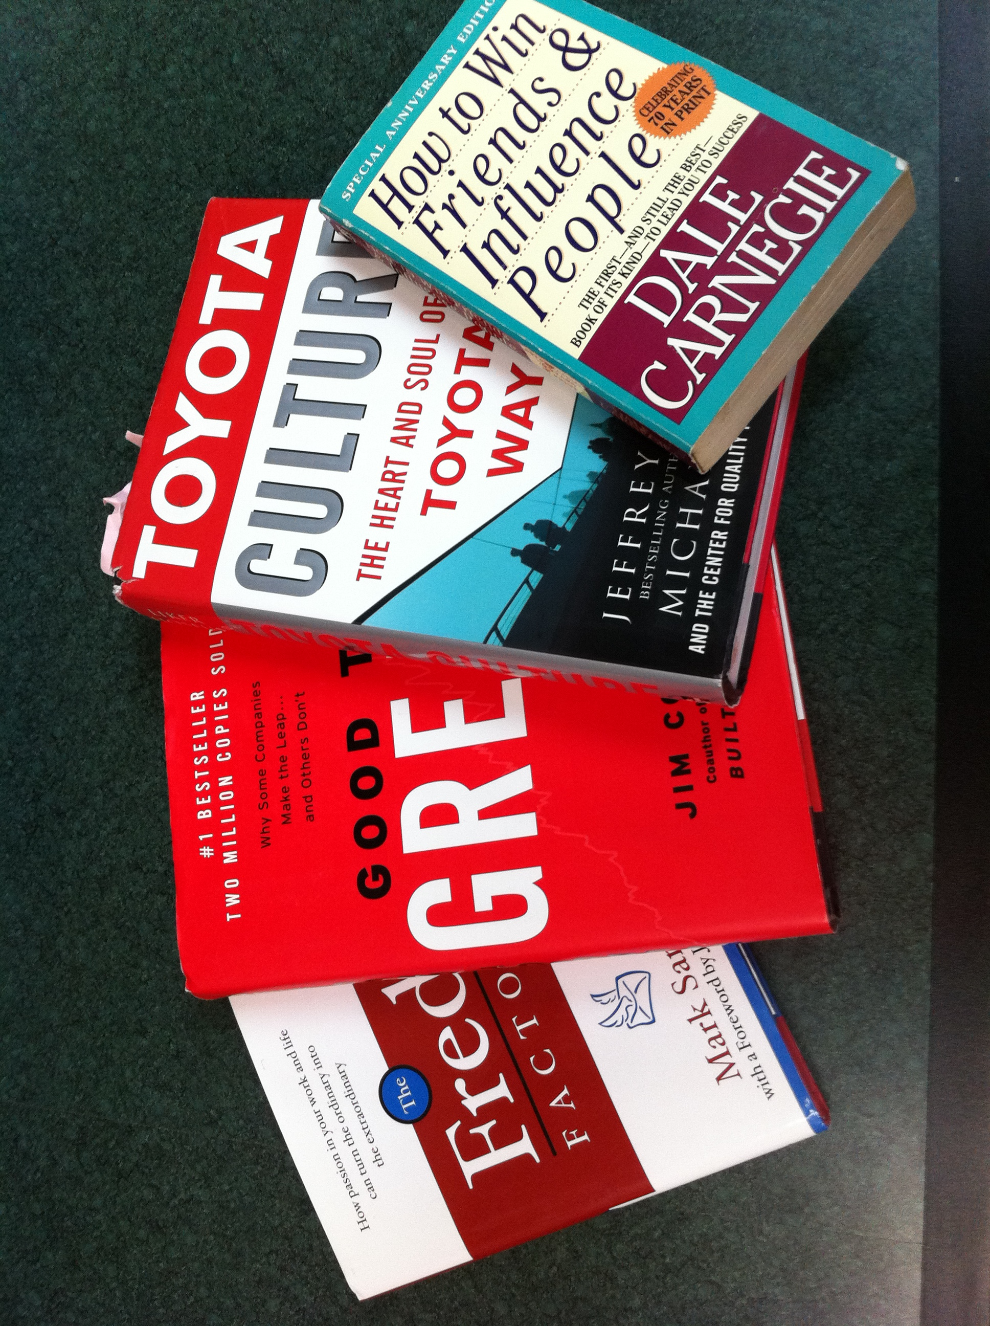

Leader: Call on one person who is not checked off yet .
Constitution Checklist

□ Aleksey K.  □ Alexey V.  □ Alisha  □ Andrey  □ Austin  □ Brady  □ Breah  □ Cathy  □ Carina  □ Cindy  □ Clint  □ Corrie  □ Daniel  □ David  □ Doug  □ Galina  □ George  □ Graham  □ Irina | □ Jenny  □ Jess  □ Jon  □ Josh  □ K-Lee  □ Kristen  □ Liliya  □ Lyuda  □ Marina  □ Marla  □ Michelle  □ Mike  □ Nico  □ Paul A.  □ Paul S.  □ Preet  □ Sandi  □ Tim  □ Yuriy  □ Vlad

Leader: Ask one team member about one
amendment per day.

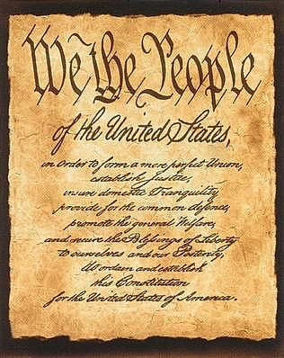
Constitution

1st Amendment (1791, George Washington):
Freedom of Religion, Speech, Press, Assembly & Petition.

2nd Amendment (1791, George Washington):
A well regulated Militia Right to Keep and Bear Arms.

3rd Amendment (1791, George Washington):
No Soldier shall be quartered without consent.

4th Amendment (1791, George Washington):
Right to be secure
No unreasonable search and seizure
No warrants without probable cause, sworn by oath
Particularly describing place to be searched, persons or things to be seized

5th Amendment (1791, George Washington):
No person shall be held to answer for Capital or Infamous
Crime without indictment by Grand Jury, Except Military
No Double Jeopardy of life or limb
Shall not be compelled to bear witness against oneself
Shall not be deprived of Life, Liberty, or Property without due process of law

6th Amendment (1791, George Washington):
Right to a speedy trial by a jury of their peers
Be informed of the accusation against them
Confront witnesses against them
Compulsory process of witnesses in their favor
Assistance of Counsel for defense

7th Amendment (1791, George Washington):
Suits of common law exceeding 20 dollars, right to trial by jury
No fact shall be re-examined, other than by rules of common law

8th Amendment (1791, George Washington):
Excessive bail shall not be set
Nor excessive fines imposed
Nor Cruel and Unusual punishment inflicted

9th Amendment (1791, George Washington):
Rights listed by the Constitution
does not deny or disparage other rights retained by the people

10th Amendment (1791, George Washington):
Power not delegated by the Constitution to the United States
Nor prohibited by it Are reserved by the States

11th Amendment (1795, George Washington):
The Judicial powers of the United States does not extend over the States
Citizens cannot sue the State
The Supreme Court adopted the Stripping Doctrine, which recognized that citizens can
Sue state officers in their official state capacity for injunctive relief.

12th Amendment (1804, Thomas Jefferson, Democrat-Republican):
President and Vice-President are chosen by the Electoral College, making the two positions cooperative, rather than first and second highest vote-getters.
If no majority of Electoral votes, 2/3 vote of House of Rep chooses President
2/3 vote of Senate chooses Vice-President
Vice-President must be eligible to become President.

13th Amendment (1865, Andrew Johnson, National Union):
Neither slavery nor involuntary servitude shall exist in the United States except as a punishment for crime. Congress has the power to enforce this by legislation.

14th Amendment (1868, Andrew Johnson, National Union):
People born or naturalized in the U.S. are citizens of the U.S. and citizens of the state in which they reside.
All citizens have equal protection under the law
Removed 3/5 counting of slaves
Counts all persons except non-taxed Indians
No person can hold office having engaged in insurrection against the U.S.
Except Congress can vote 2/3 both houses to remove such disability
The United States will not pay the debts of rebellious states.
Congress has the power to enforce this by legislation.

15th Amendment (1870, Ulysses Grant, Republican):
Right to vote shall not be denied because of race, color or previous servitude.
Congress has power to enforce this by legislation.

16th Amendment (1913, William Howard Taft, Republican):
Congress has the power to levy taxes.

17th Amendment (1913, Woodrow Wilson, Democrat):
People from each state will elect 2 Senators for that state.
Senate term will be 6 years.

18th Amendment (1919, Woodrow Wilson, Democrat):
Intoxicating liquors are prohibited

19th Amendment (1920, Woodrow Wilson, Democrat):
Right to vote not denied because of sex
Congress has the power to enforce this by legislation

20th Amendment (1933, Herbert Hoover, Republican):
Term for President starts at noon January 20th
Term for congress starts at noon January 3rd
Congress shall meet once a year starting at noon January 3rd
If President Elect dies, Vice-President shall take office

21st Amendment (1933, Franklin D. Roosevelt, Democrat):
Repeals 18th Amendment Intoxicating liquors are no longer prohibited.

22nd Amendment (1951, Harry S. Truman, Democrat):
President only elected 2 times
Serve more than two years of some other term only elected once.

23rd Amendment (1961, John F. Kennedy, Democrat):
Washington D.C. shall have 3 Electoral votes
Congress has power to enforce this by legislation.

24th Amendment (1964, Lyndon B. Johnson, Democrat):
Right to vote in primaries and elections not denied for owing tax.

25th Amendment (1967, Lyndon B. Johnson, Democrat):
Upon vacancy of President, Vice-President takes office
Upon vacancy of Vice-President, President nominates new V.P.
Congress majority vote of both houses elects
President unable to discharge office falls to V.P.
Until President gives written notice he is able to resume office

26th Amendment (1971, Richard Nixon, Republican):
Right to vote to any citizen the age of 18
Congress has power to enforce this by legislation

27th Amendment (1992, George Bush Senior, Republican):
Any law that increases the pay of legislators may not take effect until after an election.

 | Leader: Lead team in a 3-5 minute  stretch for the day.

Stretching



